**EVENT REQUEST TABLE**

***CREATE TABLE SYNTAX :***

CREATE TABLE TABLE_NAME(<column-list>

[<constraint-list>]

);

CREATE TABLE EventRequest (

EventNo VARCHAR2(8) CONSTRAINT EventNoNOTNULL not null,

DateHeld DATE CONSTRAINT DateHeldNOTNULL not null,

DateReq DATE CONSTRAINT DateReqNOTNULL not null,

FacNo VARCHAR2(8) CONSTRAINT ERFacNoNOTNULL not null,

CustNo VARCHAR2(8) CONSTRAINT ERCustNoNOTNULL not null,

DateAuth DATE,

Status VARCHAR2(10) CONSTRAINT StatusNOTNULL not null,

EstCost FLOAT(2) CONSTRAINT EstStatusNOTNULL not null,

EstAudience INTEGER CONSTRAINT EstAudienceNOTNULL not null,

BudNo VARCHAR2(8),

CONSTRAINT PK1_EventRequest2 PRIMARY KEY(EventNo),

CONSTRAINT FK1_EventRequestFacNo2 FOREIGN KEY(FacNo) REFERENCES Facility(FacNo),

CONSTRAINT FK1_EventRequestCustNo2 FOREIGN KEY(CustNo) REFERENCES Customer(CustNo),

CONSTRAINT CheckStatus

CHECK(Status IN('Pending','Denied','Approved')),

CONSTRAINT CheckEstAudience CHECK(EstAudience>0)

);

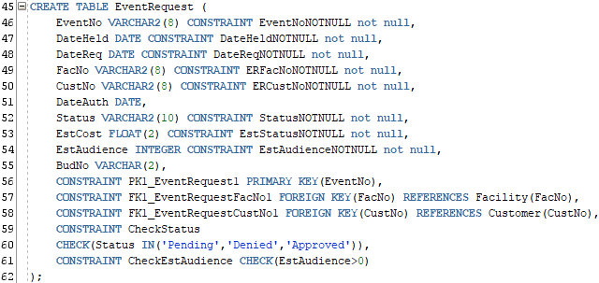

***INSERT STATEMENT :***

INSERT INTO TABLE_NAME(col_1,col_2,…col_n) VALUES (exp_1,exp_2,……exp_n);

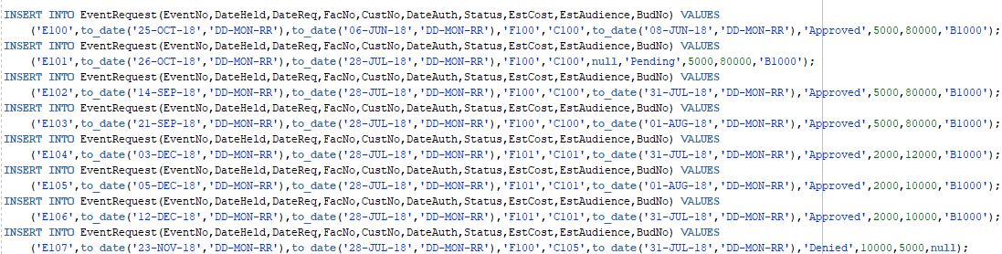

***SELECT STATEMENT :***

SELECT * FROM TABLE_NAME;



***OUTPUT :***

